A Seminar on

"ENHANCED VISUAL SECRET SHARING SCHEME via HALFTONING"

Presented by:
Ameya V. Nawale
Contact no.: 9975072089
Email ID: amey.nawale12@gmail.com
College: Pimpri-Chichwad College of Engg.

Tejas P. Nandedkar
Contact no.: 8983140634
Email ID: tejas30061992@gmail.com
College: Pimpri-Chichwad College of Engg.

INDEX

- INTRODUCTION TO VISUAL CRYPTOGRAPHY………………..........................4

- EXTENDED VISUAL CRYPTOGRAPHY FOR NATURAL IMAGES………..7
  - INTRODUCTION……………………………………………………………...7
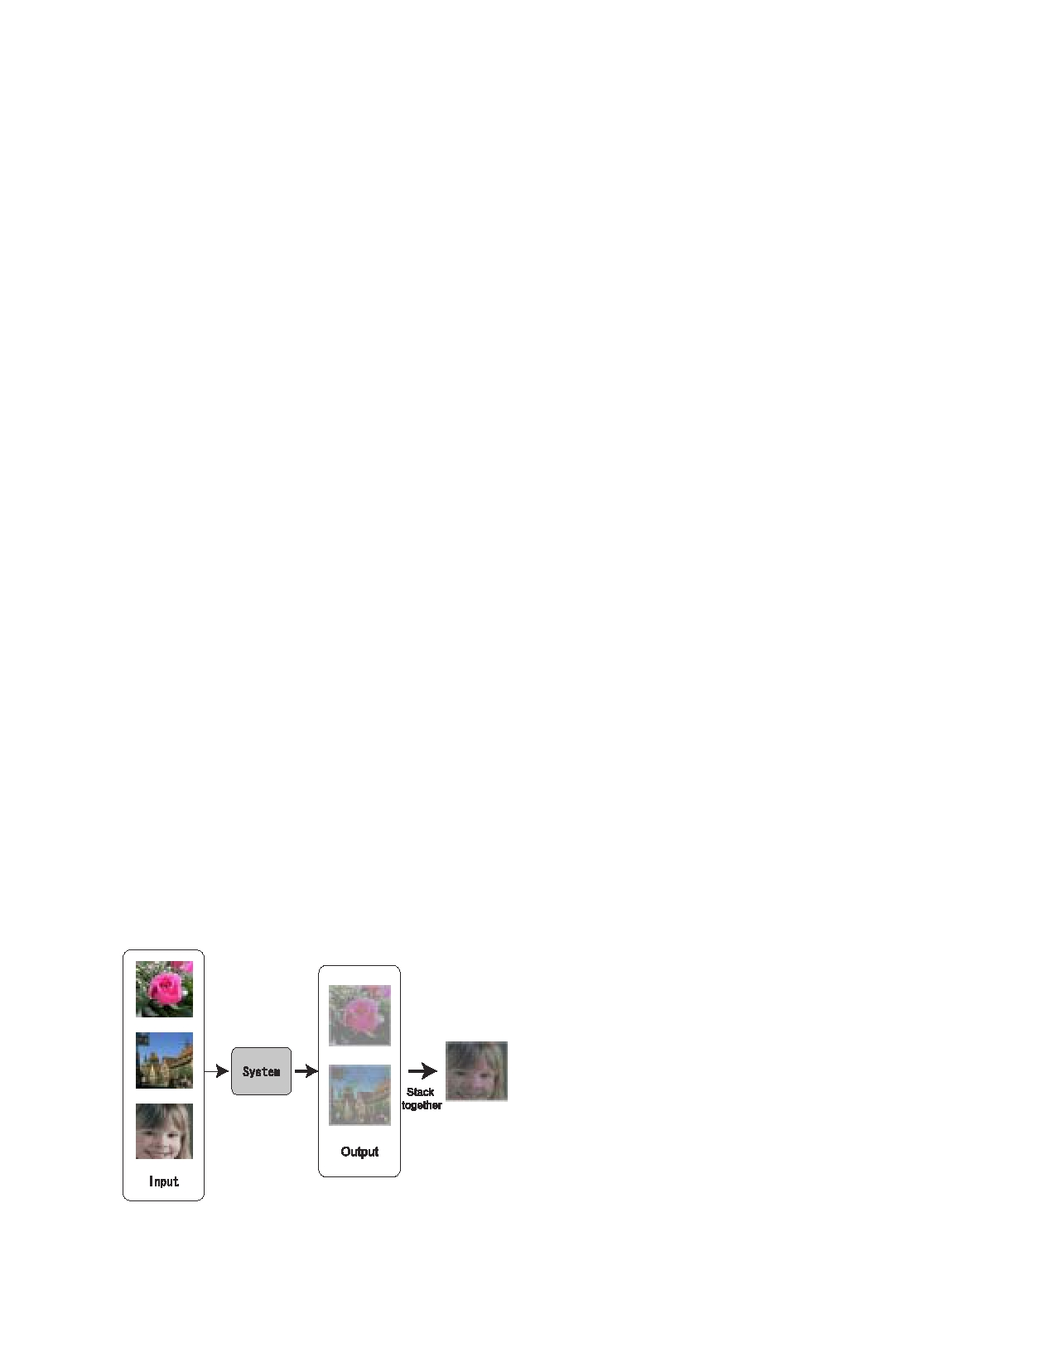
  - VISUAL CRYPTOGRAPHY………………………………………………….7
    - Visual Secret Sharing Scheme………………………………………….7
    - Extended Visual Cryptography………………………………………...9
3.2.3 Application to the Grayscale and Color Images……………………….9
- HALFTONE VISUAL CRYPTOGRAPHY………………………………………...10
  - Halftoning………………………………………………………………………..10
  - Neighborhood Process………………………………………………………….12
  - Two-out-of-two Halftone Visual Cryptography Method…………………………..12
- CONCLUSION…………………………………………………………………………13

FIGURE TABLE:
Figure No. | Description | Page No.
1. | Figure of pixel color percentage. | 1
2. | Two -out-of-two VC scheme: (a) the secret image was encoded into (b), (c) the two shares, and was (d) decoded by superimposing these two shares with 50% loss of contrast, (a) Secret image, (b) share1, (c) Share 2, (d) Decoded image. | 2
3. | The basic idea of the proposed system. | 5
4. | The halftone process:  (a) Continuous-tone input image  (b) Input pixels  (c) Input amplitude values  (d) Halftoning system  (e) Output amplitude values  (f) Output pixels  (g) Output halftone image | 8
5. | a) The Error diffusion algorithm (b) The error filter identified by the Floyd Steinberg | 8

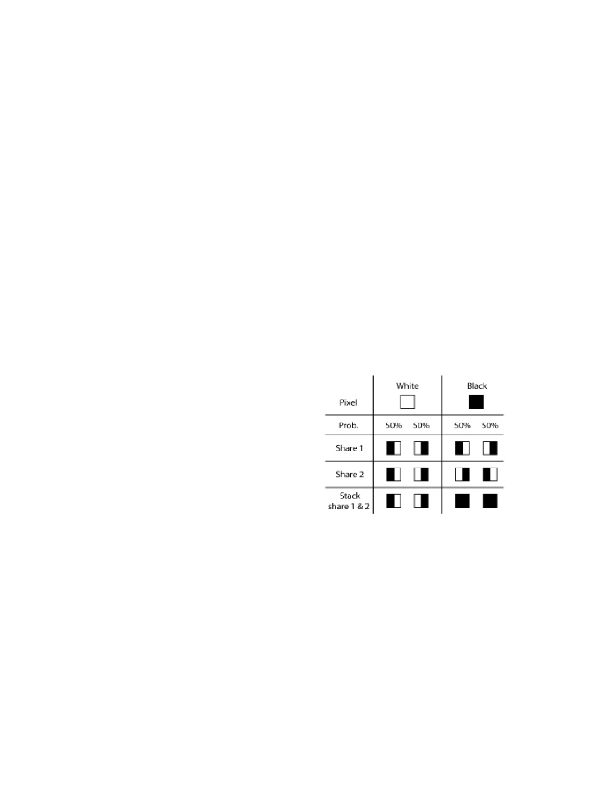
- INTRODUCTION TO VISUAL CRYPTOGRAPHY

VISUAL CRYPTOGRAPHY (VC) is a type of secret sharing scheme introduced by Naor. In a t-out-of-n scheme of VC, a secret binary image (SI) is cryptographically encoded into n shares of random binary patterns. The n shares are Xeroxed onto n transparencies, respectively, and distributed amongst n participants, one for each participant. No participant knows the share given to another participant. Any t or more participants can visually reveal the secret image by superimposing any t transparencies together. The secret cannot be decoded by any t-1 or fewer participants, even if infinite computational power is available to them. Being a type of secret sharing scheme, visual cryptography can be used in a number of applications including access control. For instance, a bank vault must be opened every day by three tellers, but for security purposes, it is desirable not to entrust any single individual with the combination. Hence, a vault-access system that requires any two of the three tellers may be desirable. This problem can be solved using a two- out-of-three threshold scheme. Aside from the obvious application to access control, secret sharing schemes are used in a number of other cryptographic protocols and applications such as threshold cryptography, private multiparty computations, electronic cash and digital elections. More specifically, visual threshold schemes have found immediate applications in certain types of cryptographic protocols, including authentication and identification, and copyright protection and watermarking.

Fig.1 Table of pixel color percentage.
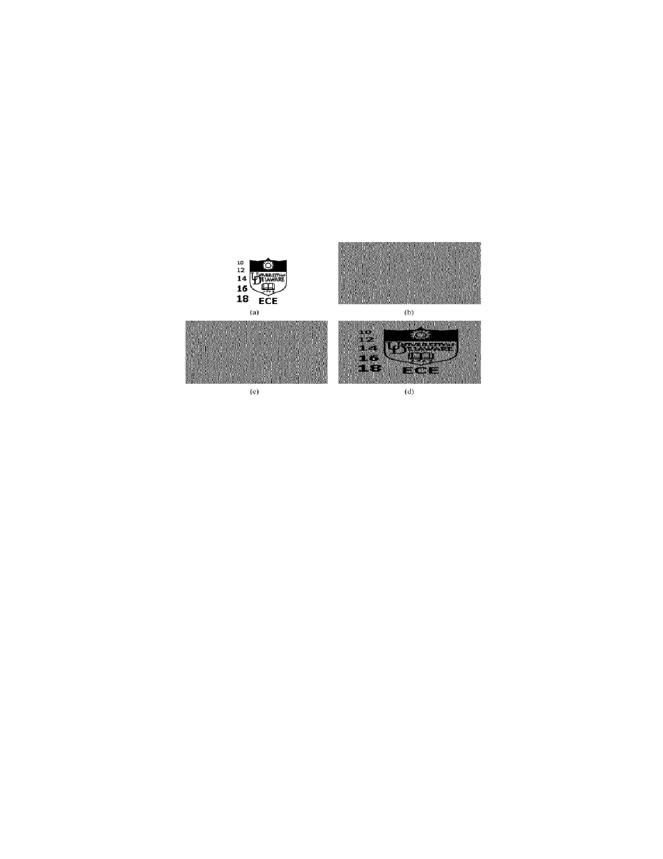
To illustrate the principles of VC, consider the simplest two out-of-two visual threshold scheme where each pixel p of the SI is encoded into a pair of sub pixels in each of the two shares.. If p is white, one of the two columns tabulated under the white pixel in Fig. 1 is selected. If p is black, one of the two columns tabulated under the black pixel is selected. In each case, the selection is performed by randomly flipping a fair coin such that each column has50% probability to be c h o s e n . Then, the first two pairs of sub- pixels in the selected column are assigned to share 1 and share 2, respectively. Since, in each share, p is encoded into a black-white or white-black pair of sub pixels with equal probabilities, independent of whether p is black or white, an individual share gives no clue as to the value of p. In addition, as each pixel is encrypted independently, no secret information can be gained by looking at groups of pixels in each share. Now consider the superposition of the two shares as shown in the last row of Fig. 1. If a pixel p is white, the superposition of the two shares always outputs one black and one white sub pixel, no matter which column of sub pixel pairs is chosen during encoding. If p is black, it yields two black sub pixels. There is a contrast loss in the reconstruction; however , the decoded pixel is readily visible.

Fig.2. Two -out-of-two VC scheme: (a) the secret image was encoded into (b), (c) the two shares, and was (d) decoded by superimposing these two shares with 50% loss of contrast, (a) Secret image, (b) share1, (c) Share 2, (d) Decoded image.

As an example, encoding the secret image shown in Fig 2(a) lead to the two shares shown in Fig. 2(b) and (c) respectively superimposing these two shares leads to the output secret as shown in Fig.2 (d). The decoded image is clearly identified, although some contrast loss is observed.
The width of the decoded image is twice that of the original secret image since each pixel p is expanded to two sub pixels in each share as shown in Fig.1 this effect is referred to as pixel expansion.
The two-out-of-two visual threshold scheme demonstrates a special case of t-out-of-n schemes. The participants in a qualified subset can recover the secret image while the participants in a forbidden subset cannot. The properties of a t-out- of-n scheme including the conditions needed for optimal contrast and the minimum pixel expansion. The concepts of VC have been recently extended such that the secret image is allowed to be a grey- level image rather than a binary image. Although the secret image is grey scale, shares are still constructed by random binary patterns. All of these VC methods suffer from a severe limitation, which hinders the objectives of VC. The limitation lies in the fact that all shares are inherently random patterns carrying no visual information, raising the suspicion of data encryption. Very recently the method referred to as extended VC has been implemented, where hypergraph colorings are used aimed at constructing meaningful binary images as shares. Extended VC, however, provides very low quality visual information in the shares, as illustrated later in this paper. Since hypergraph colorings are constructed by random distributed pixels, the resultant binary shares contain strong white noise consequently leading to inadequate results. The shares also suffer from low contrast between hyper graph black and hyper graph white pixels.
This paper focuses on developing a general halftone visual cryptography framework, where a secret binary image is encrypted into high- quality halftone images, or halftone shares. In particular, the proposed method applies the rich theory of blue noise halftoning to the construction mechanism used in conventional VC to generate halftone shares, while the security properties are still maintained. The same contrast is obtained over the whole decoded image. The halftone shares carry significant visual information to the viewers, such as landscapes, buildings, etc. The visual quality obtained by the new method is significantly better than that attained by extended VC or any other available VC method known to date.

- EXTENDED VISUAL CRYPTOGRAPHY FOR NATURAL IMAGES

Introduction
Visual cryptography [Naor95] is a kind of cryptography that can be decoded directly by the human visual system without any special calculation for decryption. As shown in Fig.1, our visual cryptography system takes three pictures as an input and generates two images which correspond to two of the three input pictures. The third picture is reconstructed by printing the two output images onto transparencies and stacking them together. This type of visual cryptography, which reconstructs the image by stacking some meaningful images together, is especially called Extended Visual Cryptography[Ateni01]. In this paper, the pictures shown on the output images are called sheets and the resulting image reconstructed by stacking the two sheets together is called the target.
Previous works on the extended visual cryptography deal with binary images such as text images, but natural images such as photographs are difficult to handle in such scheme. This paper establishes the extended visual cryptography scheme for natural images. Generally, visual cryptography suffers from the deterioration of the image quality.

Visual Cryptography
Visual Secret Sharing Scheme
The basic model of the visual cryptography consists of a several number of transparency sheets. On each transparency a ciphertext is printed which is indistinguishable from random noise. The hidden message is reconstructed by stacking a certain number of the transparencies and viewing them. The system can be used by any- one without any knowledge of cryptography and without performing any cryptographic computations.
Naor and Shamir have developed the Visual Secret Sharing Scheme (VSSS) to implement this model [Naor95]. In k out of n VSSS (which is also called (k, n) scheme), a binary image (picture or text) is transformed into n sheets of transparencies of random images. The original image becomes visible when any k sheets of the n transparencies are put together, but any combination of less than k sheets cannot reveal the original binary image.
In the scheme, one pixel of the original image is reproduced by m subpixels on the sheets. The pixel is considered "on"(transparent) if the number of transparent subpixels is more than a constant threshold, and "of" if the transparent subpixels is less than a constant lower threshhold, when the sheets are stacked together. The contrast α is the difference between the on and of threshold number of transparent pixels. Ateniese et al. has extended the (k, n) VSSS to general access structures where senders can specify all qualified and forbidden subsets of n participants[Ateni96]. Droste considered the problem of sharing more than one secret images among a set of participants, and proposed a method to reconstruct different images with different combinations of sheets[S.Dro96]. Hofmeister has discussed to maximize the contrast α using linear programming in the cases of k∈{3, 4, n}[Hofme97].

Figure 3: The basic idea of the proposed system.

Extended Visual Cryptography
Naor and Shamir have mentioned an extention of the model which conceals the very existence of the secret message [Naor95]. That is, each sheet carries some meaningful images rather than random dots. They referred to the (2, 2) example with the number of subpixels m = 4. Ateniese has formalized this framework as the Extended Visual Cryptography and developed a scheme for general access structures[Ateni01]. They also discuss the trade-of between the contrast of the each images on the sheets and that of the resulting image when stacked together in (k, k) cases.

Application to the Grayscale and Color Images
A few researches have discussed the visual cryptography for grayscale and color images. Naor and Shamir mentioned the extention of their scheme to grayscale images[Naor95]. That is, to represent the graylevels of the hidden image by controlling the way how the opaque subpixels of the sheets are stacked together. The grayscale version of the visual cryptography is fundamentally proposed in the paper.
There are some researches that deal with color images [Naor96, Koga98, E.R.V97, Rijme96]. Naor and Shamir discussed the visual cryptogra- phy scheme which reconstructs a message with two colors, by arranging the colored or transparent subpixels[Naor96]. Koga et al. devised a lattice-based (k, n) scheme[Koga98]. The approach by Verheul and van Tilborg[E.R.V97] is basically similar to Koga's. Both approaches assign a color to a subpixel at a certain position, which means that displaying m colors uses m− 1 subpixels. The resulting pixels contain one colored subpixel and the rest of the subpixels are black. Therefore the more colors are used, the worse the contrast of the images becomes significantly. Their approaches cannot be applied to the extended visual cryptography, either. Rijmen and Preneel talked about enabling multicolor with relatively less subpixels(24 colors with m = 4)[Rijme96]. However each sheet must contain color random images, which means applying this approach to the extended visual cryptography is impossible.
This paper focuses on the (2, 2) scheme and discusses the method to deal with the natural images with intermediate graylevels. It also shows how to enhance the contrast.

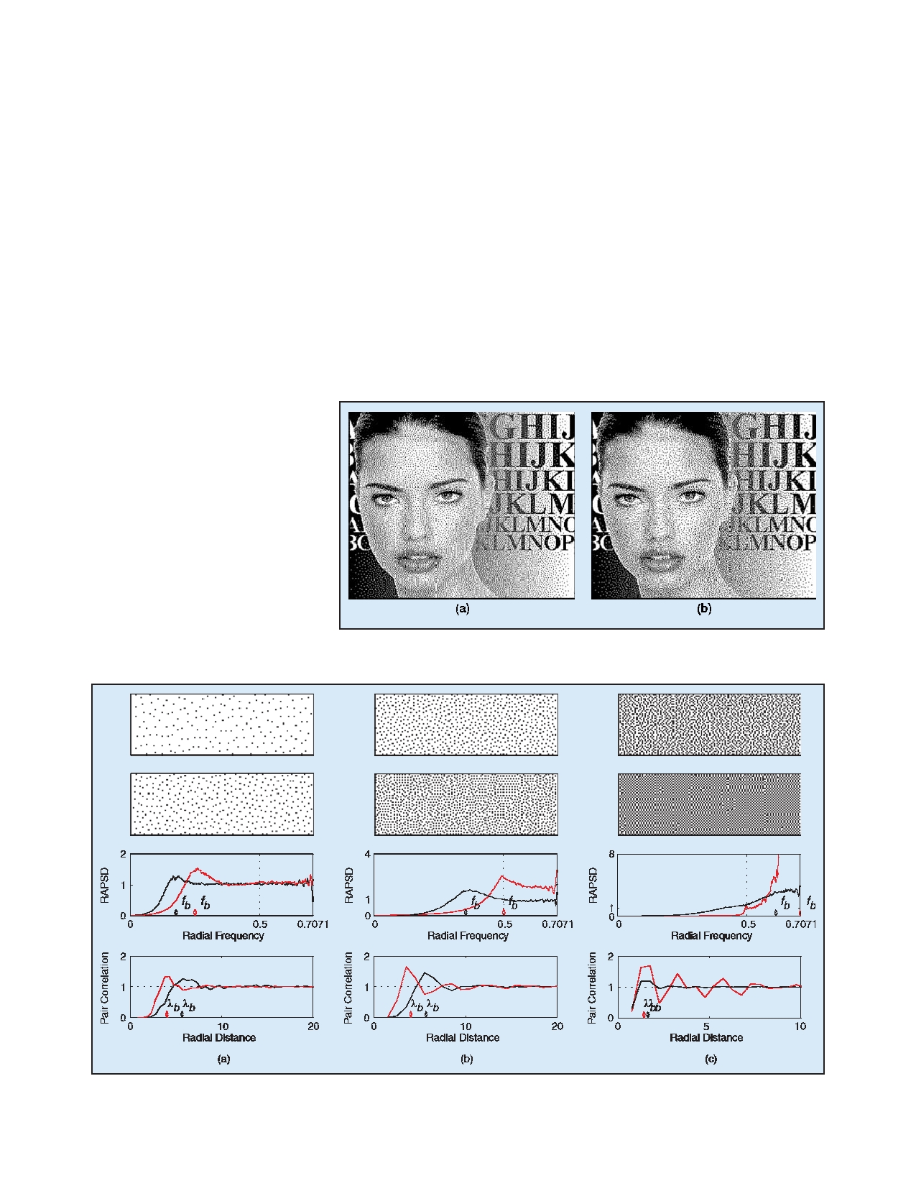
- HALFTONE VISUAL CRYPTOGRAPHY

Halftoning:
Halftoning is the process of transforming an image with greater amplitude resolution to one with lesser amplitude resolution. This has been practiced for over a hundred years in the printing industry; the solution for displaying continuous- tone images with only black or white dots. In digital printing and display systems today the problem is essentially the same: how to produce the illusion of the original tonal quality of a image by judicious placement of dots. Digital implementation of halftone processes are also called "dithering", and the terms are often used interchangeably. Fig 3 illustrates the role of a halftoning system. A continuous tone image (a) is digitally represented by discrete sample (b) called picture elements or "pixels". The amplitude of each pixel is represented by an integer (c); in this example the amplitude values are represented with8 bits, ranging from 0 (black) to 255 (white). These integer amplitude values are the input to a halftoning system (d) that performs some processing to produce output pixels (f) with amplitude values (e) of, in this case, 1 bit per pixel. The goal of the halftoning system is to generate an image (g) that is similar to the original input image (a). The perceptually similar criterion is a very important one and is linked to the characteristics of human vision.

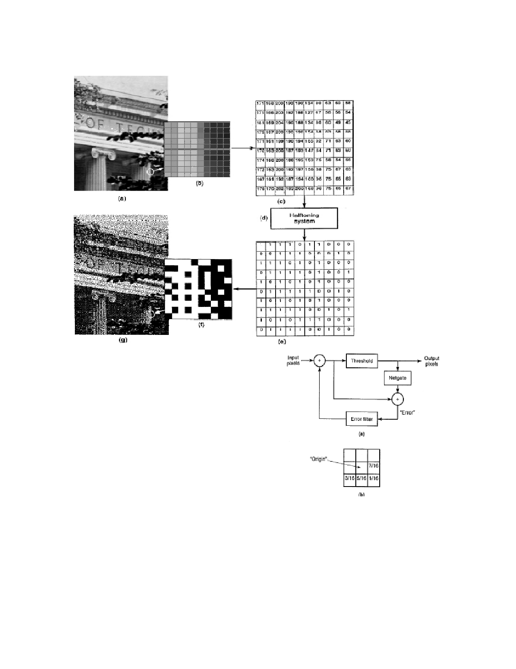

Fig. 4.The halftone process:

(a) Continuous-tone input image
(b) Input pixels
(c) Input amplitude values
(d) Halftoning system
(e) Output amplitude values
(f) Output pixels
(g) Output halftone image
Fig.5. (a) The Error diffusion algorithm (b) The error filter identified by the Floyd Steinberg

Neighborhood Process:
In image processing, a point process is an operation that uses as it's only input the value of the current pixel; a neighborhood process uses as input the values of the current pixel along with the values of pixel surrounding it. One neighborhood process that attempts to generate blue noise is the error diffusion algorithm. A graphical illustration of the algorithm is shown in Fig 4. assuming that the input signal varies from g=0 to g=1,the threshold block simple sets the output to 0 for values less than ½ and to 1 for values greater than or equal to 1/2.. The binary output signal is subtracted from the prethreshold signal to form an error.
This error is "diffused" into yet to be considered input values as governed by the error filter. The signal consisting of past error values is passed through this filter to produce a correction factor to be added to future input values. This algorithm was first introduced by Floyd and Steinberg, who also proposed the error filter shown in Fig 4(b). The algorithm processes pixels in a raster order, so the only nonzero filter elements are those in front of and below the current pixel. As with all error filters, the elements must sum to one.

- CONCLUSION

In this paper, a general framework of halftone visual cryptography is proposed. Applying the rich theory of blue noise halftoning into the construction mechanism of conventional VC, the proposed method generates visually pleasing halftone shares carrying significant visual information. The obtained visual quality is better than that attained by any other available VC method known to date. The new method can be broadly used in a number of visual secret sharing applications which require high-quality visual images, such as watermarking, electronic cash, etc.

